**DAILY ONLINE ACTIVITIES SUMMARY**

|  |  |  |  |  |  |  |
| --- | --- | --- | --- | --- | --- | --- |
| **Date:** | **15/06/2020** | | | **Name:** | **Pratibha Shetti** | |
| **Sem & Sec** | **IV sem & B section** | | | **USN:** | **4AL18CS062** | |
| **Online Test Summary** | | | | | | |
| **Subject** | **-** | | | | | |
| **Max. Marks** | **30** | **Score** | | | **-** | |
| **Certification Course Summary** | | | | | | |
| **Course** | **Introduction to Ethical Hacking** | | | | | |
| **Certificate Provider** | **Greatlearning academy** | | **Duration** | | | **4.0 hours** |
| **Coding Challenges** | | | | | | |
| **Problem Statement1:** Write a Java Program to find if string is K-Palindrome or not.  **Problem Statement2:** Write a C Program to perform the following operations on Triply Linked.  **Problem Statement3:** Write a C Program to implement the Binary Reversal. | | | | | | |
| **Status: Executed** | | | | | | |
| **Uploaded the report in Github** | | | **YES** | | | |
| **If yes Repository name** | | | |  | | --- | | <https://github.com/pratibhashetty-123/Lockdown-coding-java>  <https://github.com/pratibhashetty-123/Lockdown-coding-for-C> | | | | |
| **Uploaded the report in slack** | | | **YES** | | | |

Online Test Summary: No internals conducted today.

Online Certification Course Summary: Today I have completed the course and attempted the quiz to get the certificate.

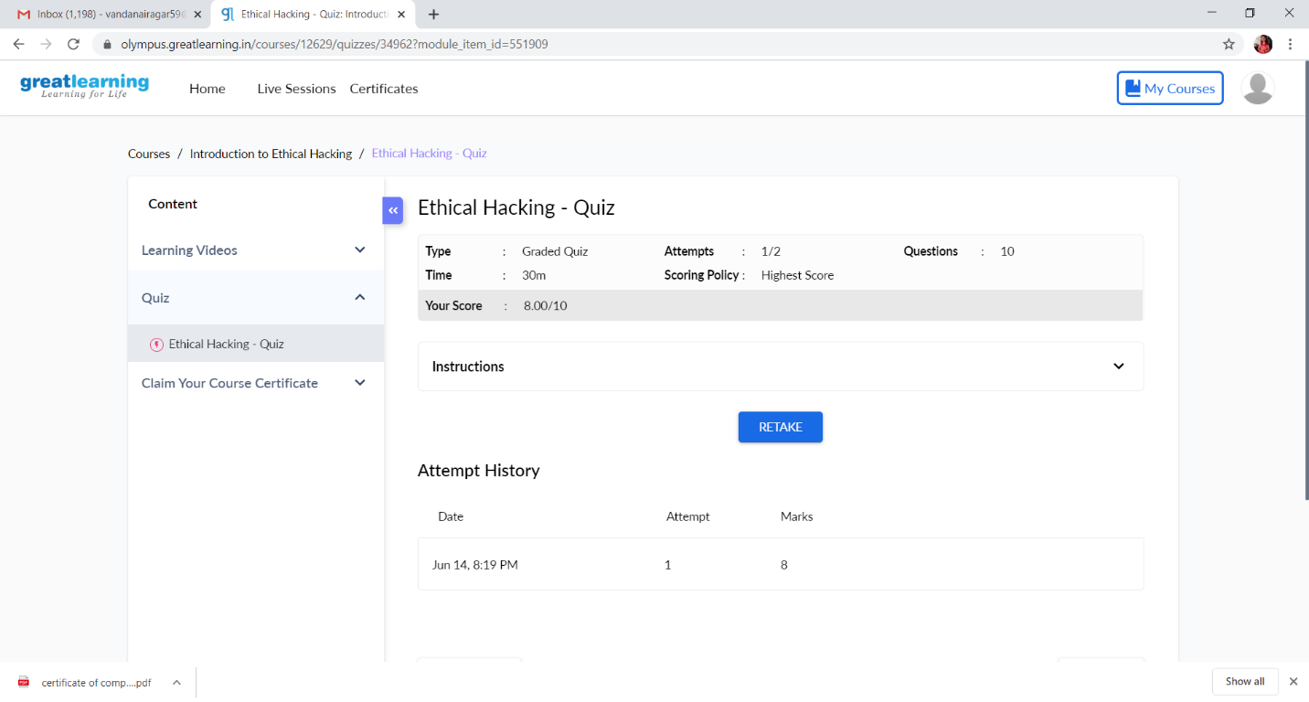

This is the Snap Shot of the quiz attempted and grade obtained.

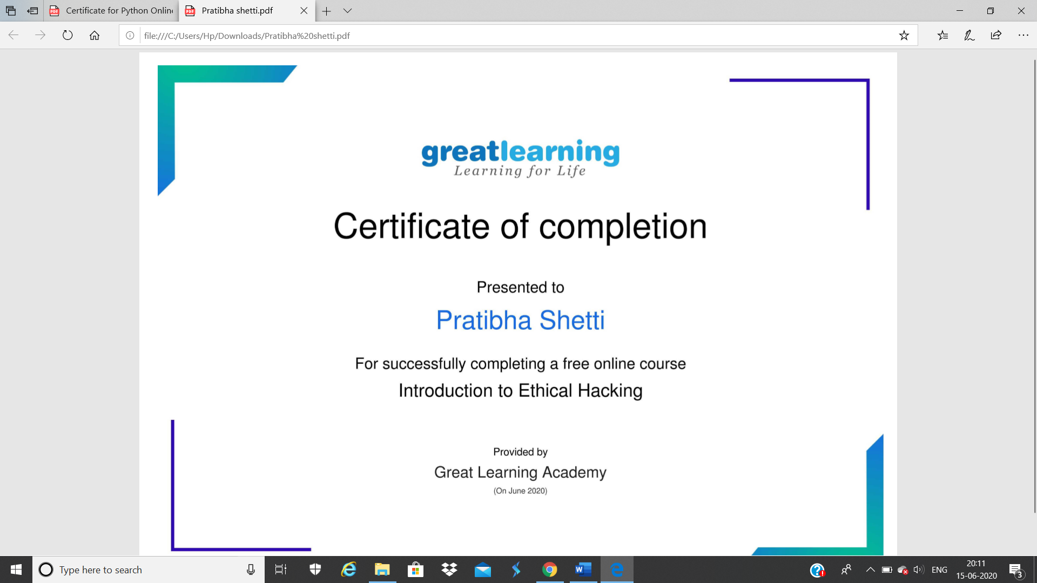

This is the Snap Shot of the certificate of completion.

Online Coding Summary: **Today I had received one program from prof. Shilpa CSE Dept. and prof.Venkatesh CSE Dept. The program is mentioned above in the coding challenges(pg.01). I have also uploaded it to my Github repository.**

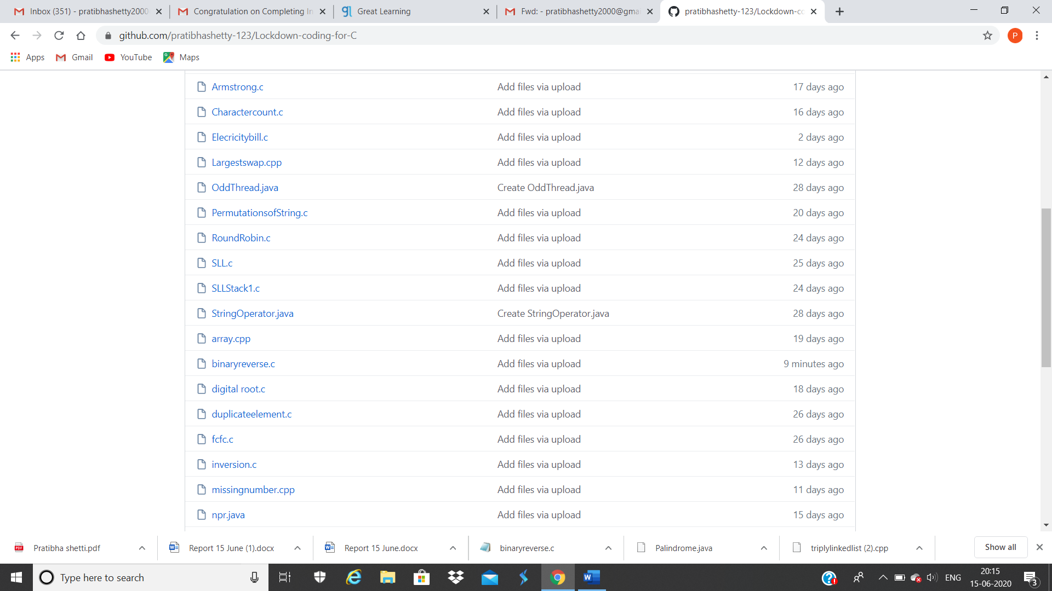

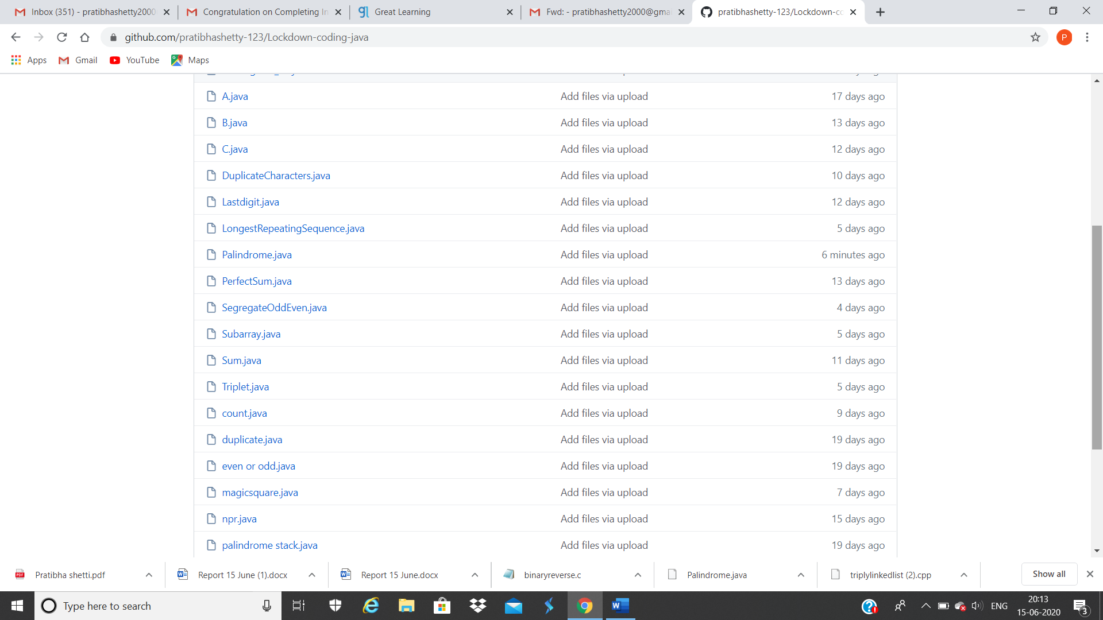

**These are the snap shot of my Github repository** were I have uploaded the code. File name is binaryreverse.c, triplylinkedlist.cpp and Palindrome.java